PWM-CM3 model in LTspice

**Simulation Description**

Author:

**Mark Dimattina**

**REVISION HISTORY**

|  |  |  |  |
| --- | --- | --- | --- |
| **Issue** | **Date** | **Change** | **Prepared** |
| 0.01 | 22/05/2024 | First Issue | MD |
| 0.02 | 01/10/2024 |  |  |
|  |  |  |  |
|  |  |  |  |
|  |  |  |  |
|  |  |  |  |
|  |  |  |  |
|  |  |  |  |
|  |  |  |  |
|  |  |  |  |
|  |  |  |  |
|  |  |  |  |
|  |  |  |  |
|  |  |  |  |
|  |  |  |  |

**CONTENTS**

1 Introduction 4

2 Buck 5

3 Boost 6

3.1 Flyback 7

3.2 PWM-CM3 Description 8

3.2.1 Peak Current 8

3.2.2 Duty Cycle 8

3.2.3 Mode Selection 9

3.2.4 Current Calculation 9

3.2.5 Induced Inductor Voltage 10

4 PWM-CM3 Verfication 11

4.1 Buck 11

4.2 Sub-Harmonic Oscillations 13

5 PWM-CM Boost 14

5.1 Sub-Harmonic Oscillations 17

6 Buck-Boost Negative Output 18

7 Buck-Boost Negative Input 20

8 Flyback 22

**FIGURES**

Figure 1 PWM-CM3 4

Figure 2 Buck-CM3 5

Figure 3 Buck Currents 5

Figure 4 Boost-CM3 6

Figure 5 Boost Currents 6

Figure 6 Flyback-CM3 7

Figure 7 Flyback Currents 7

Figure 8 Current Mode Peak Current 8

Figure 9 Duty Cycle 8

Figure 10 Mode Selection 9

Figure 11 Current Calculation 9

Figure 12 Induced Inductor Voltage 10

Figure 13 Corrected Inductor Voltage 10

Figure 14 Parameters 11

Figure 15 Ideal Discrete Time 11

Figure 16 PWM-CM3 11

Figure 17 Comparative Buck Response 12

Figure 18 Sub-harmonic Oscillations in a Buck Converter 13

Figure 19 Boost Parameters 14

Figure 20 Boost RT9297 Example 14

Figure 21 Boost PWM-CM3 Configuration 15

Figure 22 Boost RT9297 Example, Bode Plot 15

Figure 23 Boost RT9297 Example, Transient Response 16

Figure 24 Boost Sub-harmonic oscillations 17

Figure 25 Buck-Boost Negative Output Parameters 18

Figure 26 Buck-Boost Negative Output 18

Figure 27 Buck-Boost, Neg O/P, Bode Plot 18

Figure 28 Buck-Boost, Transient Response 19

Figure 29 Buck-Boost Negative Input Parameters 20

Figure 30 Buck-Boost Negative Input 20

Figure 31 Buck-Boost, Neg I/P, Input Bode Plot 21

Figure 32 Flyback Input Parameters 22

Figure 33 Flyback Ideal Discrete Time 22

Figure 34 Flyback_CM3 Average Model 23

Figure 35 Flyback PWM-CM3 Configuration 23

Figure 36 Flyback, Transient Response 24

Figure 37 Flyback, AC Response 25

**TABLES**

No table of figures entries found.

# Introduction

PWM-CM3 is an Averaged Current Mode models that can be used for Current Mode control in Buck, Boost or Flyback configuration. The model is similar to Christophe Basso’s PWM-CM model but instead of connecting the PWM-CM model with rather confusing connections for Boost, Flyback operation the PWM-CM3 model determines the magnetizing and de-magnetizing currents. These currents are connected to suit the power supply operation (ie Buck, Boost, Flyback etc.) and some possible operations as shown in section 2 Configurations. Spice is used to iteratively solve the duty cycle, peak inductor current, Continuous Mode Inductor Voltage and Magnetizing/Demagnetizing currents.

The model has a ground referenced control voltage input (Vc), an inductor magnetizing voltage (V_mag) input, an inductor demagnetizing voltage (V_demag) input, and 2 output voltages (I_mag, I_demag) that represent the averaged magnetizing and demagnetizing currents.

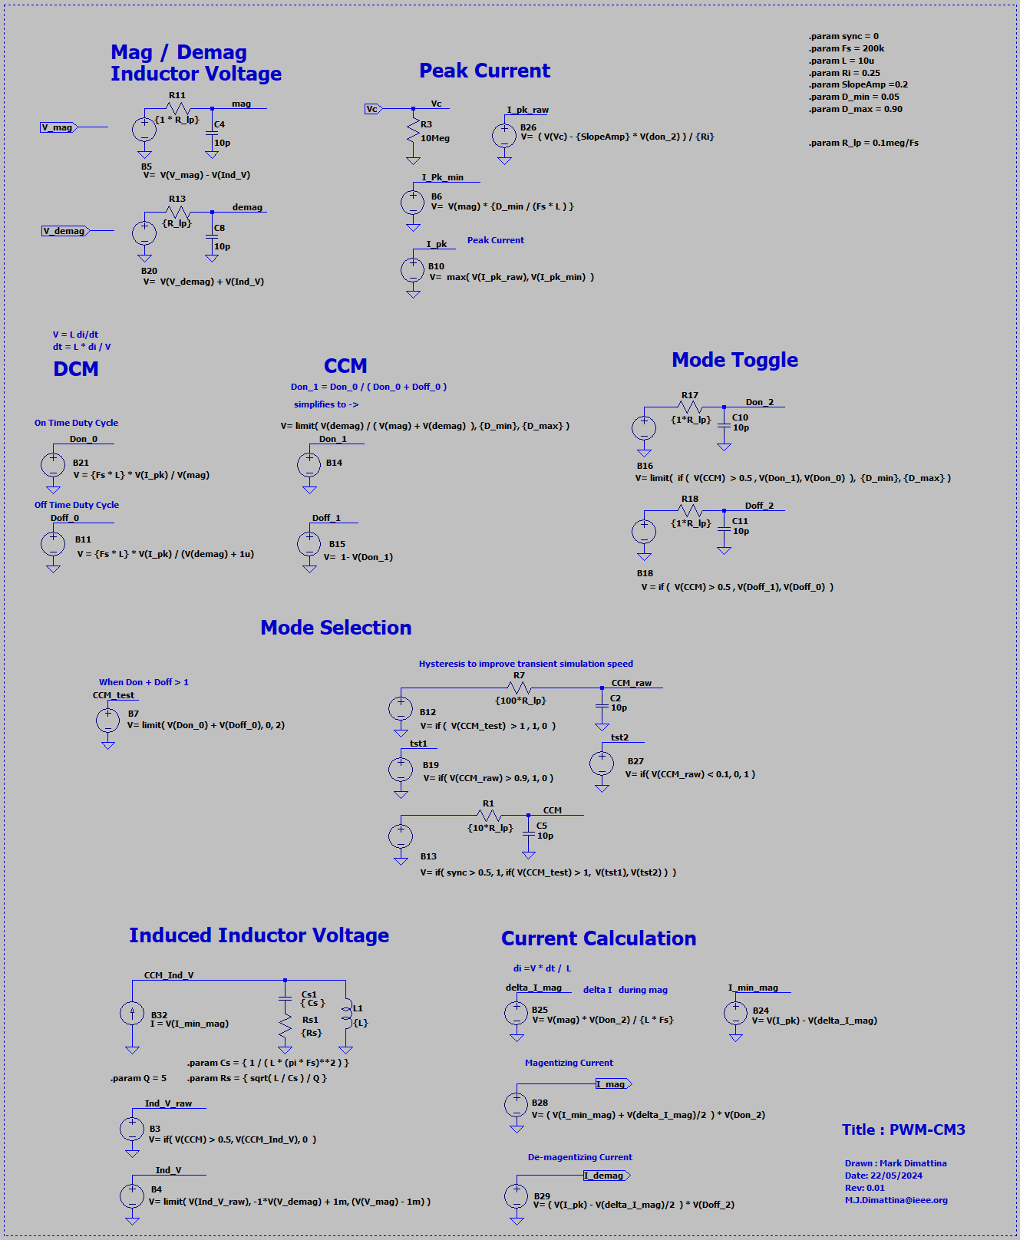

Figure PWM-CM3

# Configurations

## Buck

Figure Buck-CM3

I_mag

I_demag

A

C

P

Figure Buck Currents

For the Buck converter, the input current is the Magnetizing current (I mag) and the output current is both the Magnetizing and Demagnetizing currents (I_mag + I_demag).

## Boost

Figure Boost-CM3

I_mag

I_demag

A

C

P

Figure Boost Currents

For the Buck converter, the input current is the Magnetizing and Demagnetizing currents (I_mag + I_demag) and the output current is the Demagnetizing current (I_demag).

## Flyback

Figure Flyback-CM3

I_mag

I_demag

Figure Flyback Currents

For the Flyback converter is similar to the Boost where, the input current is the Magnetizing current (I_mag) and the output current is the Demagnetizing current (I_demag) but the output current is connected differently. An isolation stage has been added for a typical flyback configuration.

# PWM-CM3 Description

### Peak Current

|  |  |
| --- | --- |
|  | For a slope compensated Current Mode the peak inductor current is (Vc – SlopeAmp * Don ) / Ri where:  Vc = control voltage  Ri = equivalent sense resistor  Don = On-Time duty cycle  SlopeAmp = value of the slope compensation for Don = 1  But the peak current cannot go below the value determined by the minimum duty cycle and the V = L di/dt relationship. |
| Figure 8 Current Mode Peak Current |  |

### Duty Cycle

Figure Duty Cycle

The On Time duty cycle (Don) is when the magnetizing current is flowing ie. the current in the inductor is increasing.

The Off Time duty cycle (Doff) is when the demagnetizing current is flowing ie. the current in the inductor is decreasing.

The model has two modes of operation Discontinuous Current Mode (DCM) and Continuous Current Mode (CCM). The DCM and CCM duty cycles are determined and CCM is selected if the total DCM Don and Doff duty is greater than one otherwise the DCM values are used.

The DCM Don and Doff duty cycles are calculated using the V = L di/dt relationship. It is easily seen that the magnitude of the current slope is proportional to the voltage across the inductor and inversely proportional to the relative duty cycle. The CCM Don duty cycle makes use of this so Don can be calculated from the inductors magnetizing and demagnetizing voltage.

Note: The model occasionally has difficulty finding a DC bias point and will often stop during a Transient simulation with a “Time step too small error”. This occurrence of this error can be reduced by adding single pole, low pass filters to some signals.

### Mode Selection

Figure Mode Selection

While the Mode Selection signal CCM is simply true (1) when the DCM Don + Doff is greater than 1, hysteresis has been added to stop the CCM signal quickly toggling back on forth on a DCM-CCM transition. This improves the transient simulation speed.

### Current Calculation

Figure Current Calculation

The change in inductor current (delta_I_mag) or Peak-to-Peak current can be found using the V = L di/dt relationship. Then the minimum inductor current (I_min_mag) can be calculated and finally the magnetizing current (I_mag) and demagnetizing current (I_demag) can be calculated.

### Induced Inductor Voltage

Figure Induced Inductor Voltage

In CCM the inductor current does not return to zero and a change in the minimum inductor current will result in a voltage across the inductor, effectively changing the inductors magnetizing and demagnetizing voltage. This can be accounted for by passing the calculated minimum inductor current (I_min_mag) through an inductor, measuring the inductor voltage and then adding (or subtracting) the I_min_mag induced inductor voltage from the steady state inductor voltage.

Spice does not like an inductor being driven from a current source, so a capacitor Cs needs to be added in parallel with the inductor. The value of the capacitor was chosen to resonant at half the switching frequency. To reduce ringing, a Q value of 5 was chosen for the resonant circuit. These values for Cs and Rs seem to result in a large change in the AC analysis phase response when sub-harmonic oscillations are present.

Figure Corrected Inductor Voltage

# PWM-CM3 Verfication

## Buck

To test the averaged model accuracy, it was compared against an ideal discrete time model.

Figure Parameters

Figure Ideal Discrete Time

Figure PWM-CM3

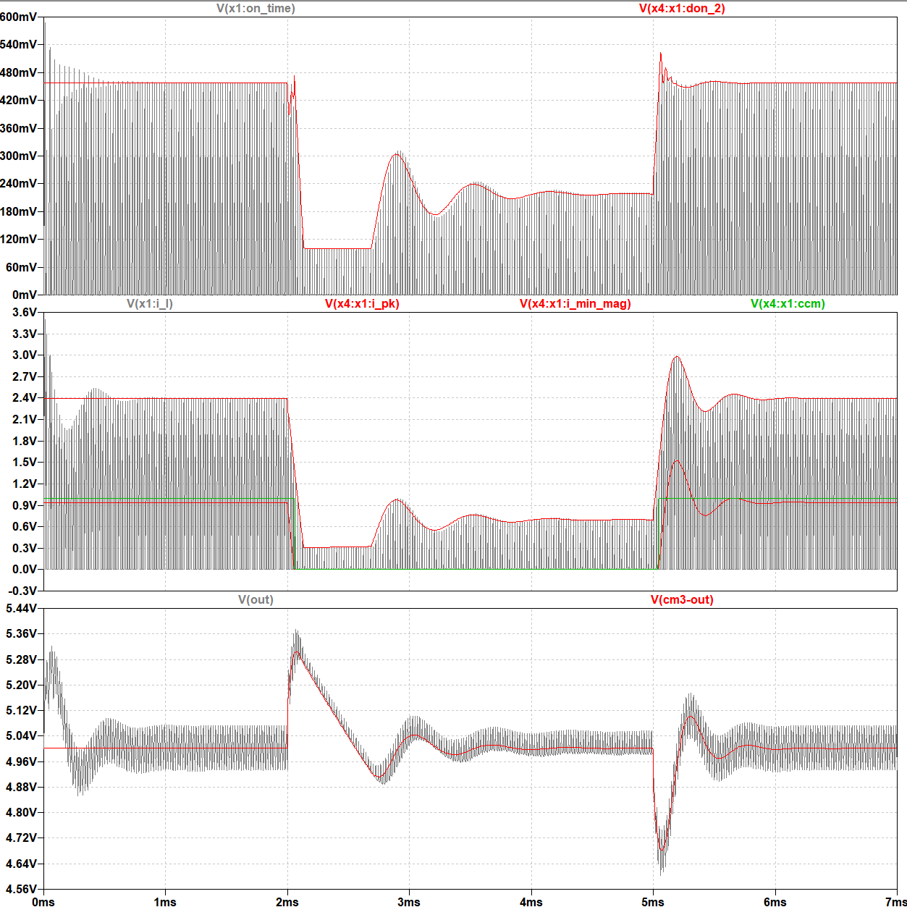

Figure Comparative Buck Response

Even when the supply is running close to sub-harmonic oscillations the averaged model is very close to the discrete time model.

## Sub-Harmonic Oscillations

The AC Open Loop Response Buck converter shows a radically different phase response when sub-harmonic oscillations are present close to the operating frequency of the power supply. It may be that the displayed phase response needs to be shifted negative 360 deg. In this case the converter is inherently unstable. This may be useful in detecting the presence of sub-harmonic oscillations from the AC Open Loop Response. In this case sub-harmonic oscillations are present when *Vout* = 6 V but not at *Vout* = 5 V.

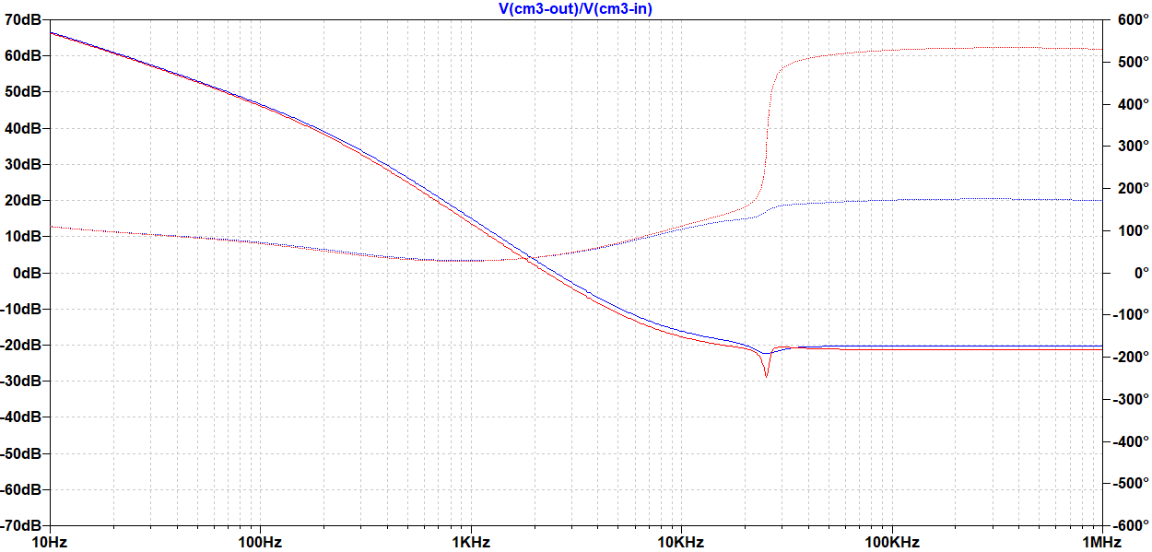

Vout = 6 V

Vout = 5 V

Figure Sub-harmonic Oscillations in a Buck Converter

# PWM-CM Boost

Like the PWM-CM and PWM-CM2, the PWM-CM3 can be configured to operate as a Boost converter.

Figure Boost Parameters

Figure Boost RT9297 Example

Figure Boost PWM-CM3 Configuration

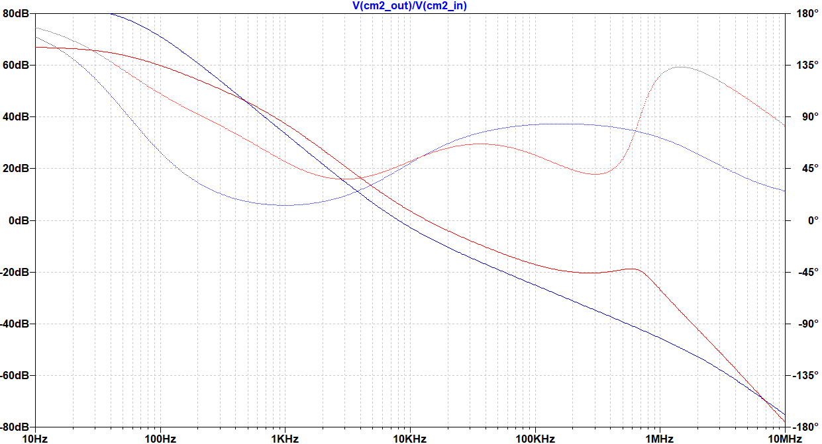

Iout = 500 mA

Iout = 30 mA

Figure Boost RT9297 Example, Bode Plot

The lower frequency at the 0dB point of the DCM response (30 mA) in the Bode plot predicts the slower DCM Transient Response.

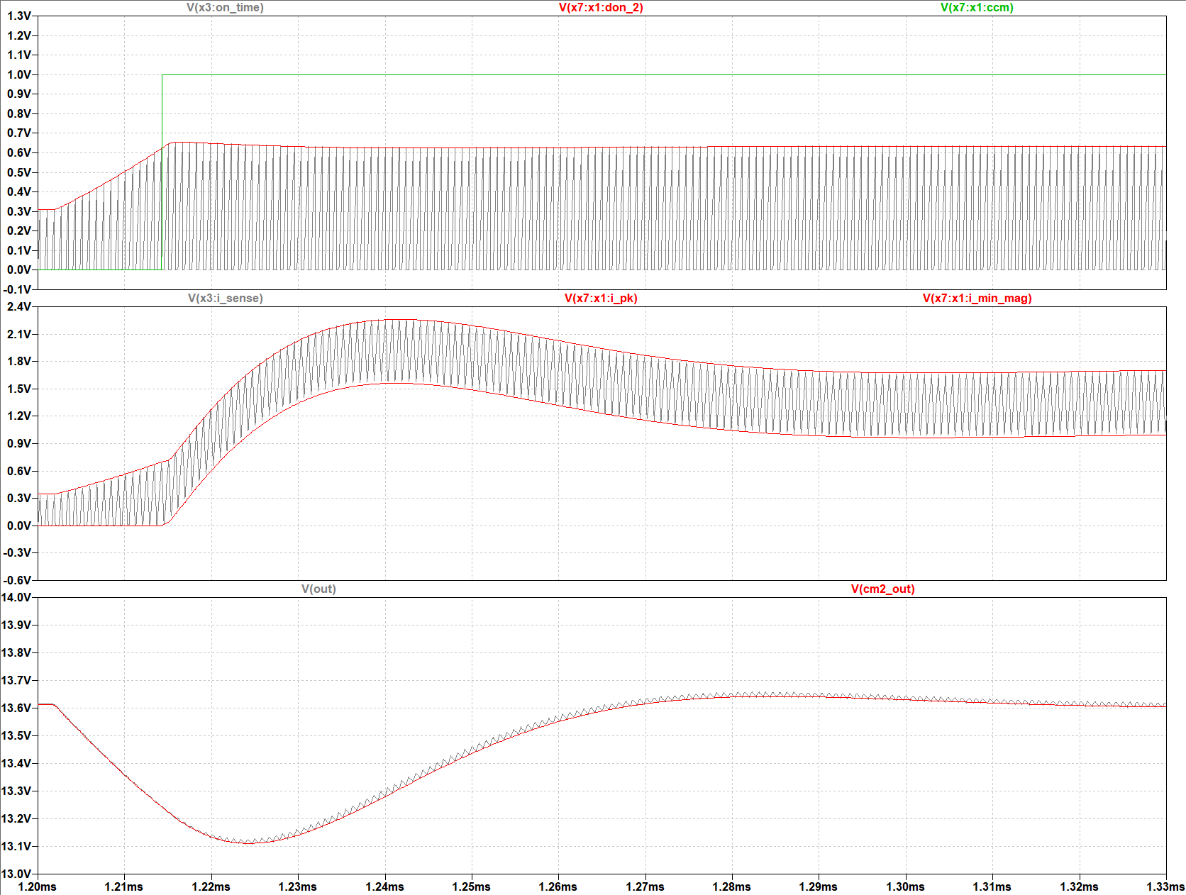

Figure Boost RT9297 Example, Transient Response

## Sub-Harmonic Oscillations

Setting the slope compensation ramp to 0 V and comparing the 500-mA CCM responses for *Vout* = 8 V and 12 V provides a good example of a response without sub-harmonic oscillations (*Vout* = 8 V) and a response with sub-harmonic oscillations (*Vout* = 12 V). When the phase increases close to Fs, sub-harmonic oscillations will be present in the output.

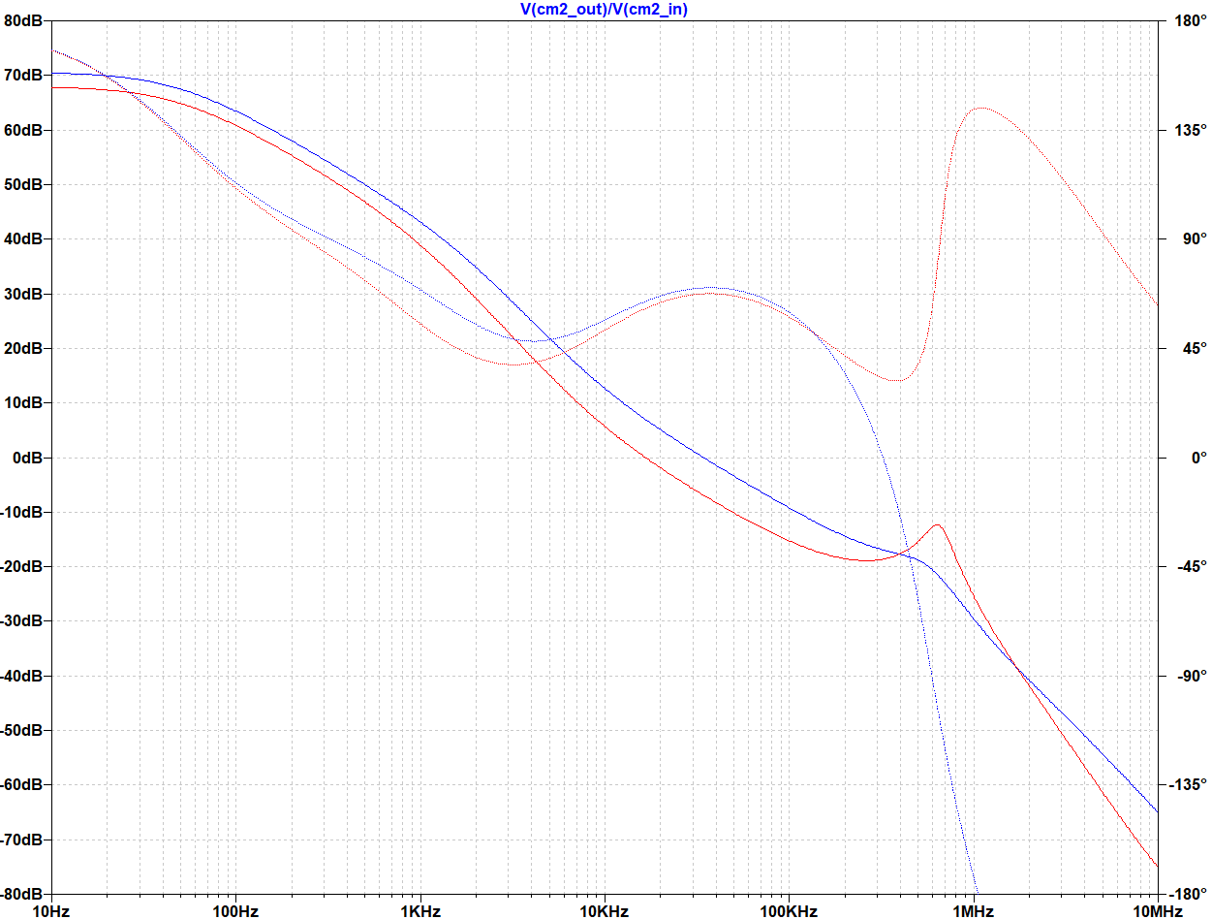

Vout = 12 V

Vout = 8 V

Figure Boost Sub-harmonic oscillations

# Buck-Boost Negative Output

The Buck-Boost with negative output configuration for the PWM-CM3 is shown in Figure 26. The PWM-CM2 control voltage *CM_Vc* is still referenced to GND but for most Buck controllers the error amp is referenced to the negative rail *CM_p*. In this example the feedback voltage is “level shifted” to GND potential via *E1*.

Figure Buck-Boost Negative Output Parameters

Figure Buck-Boost Negative Output

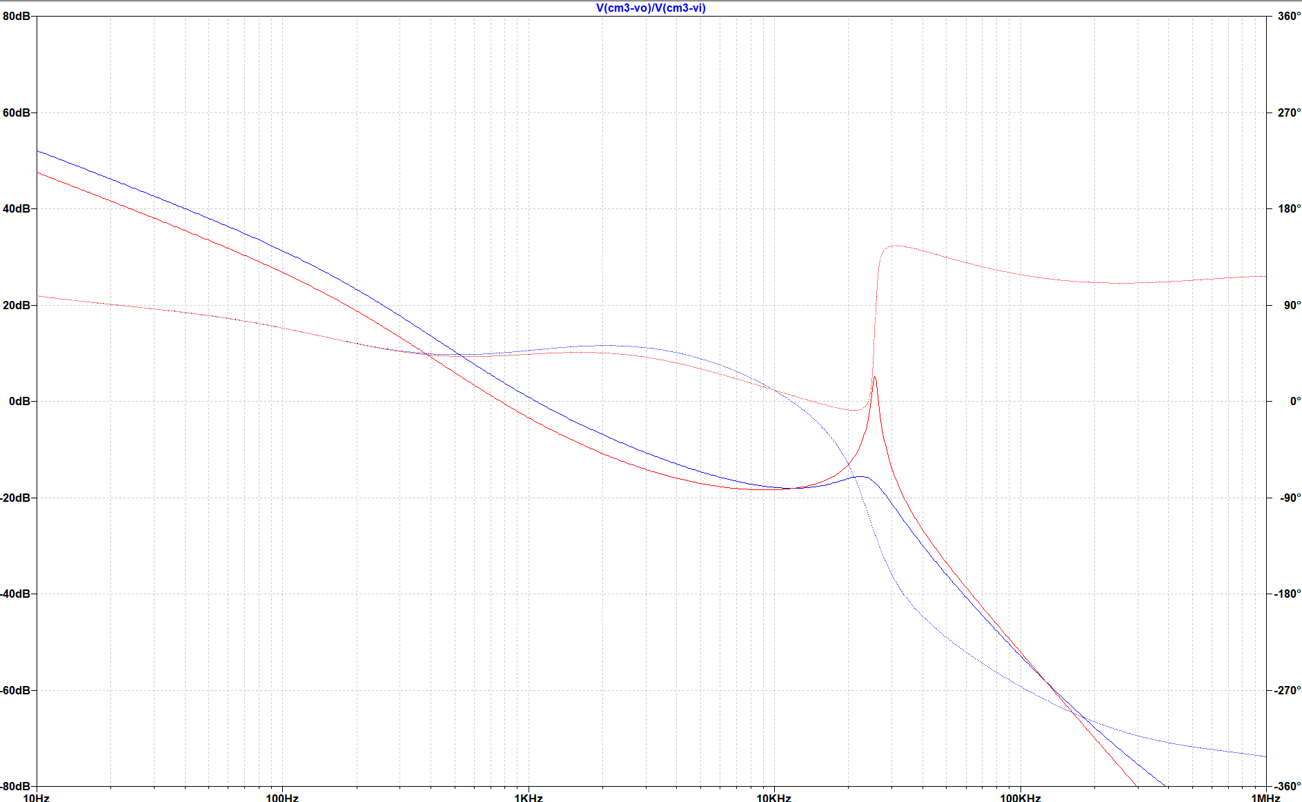

Vout = 7 V

Vout = 5 V

Figure Buck-Boost, Neg O/P, Bode Plot

When the phase increases close to Fs, sub-harmonic oscillations will be present in the output.

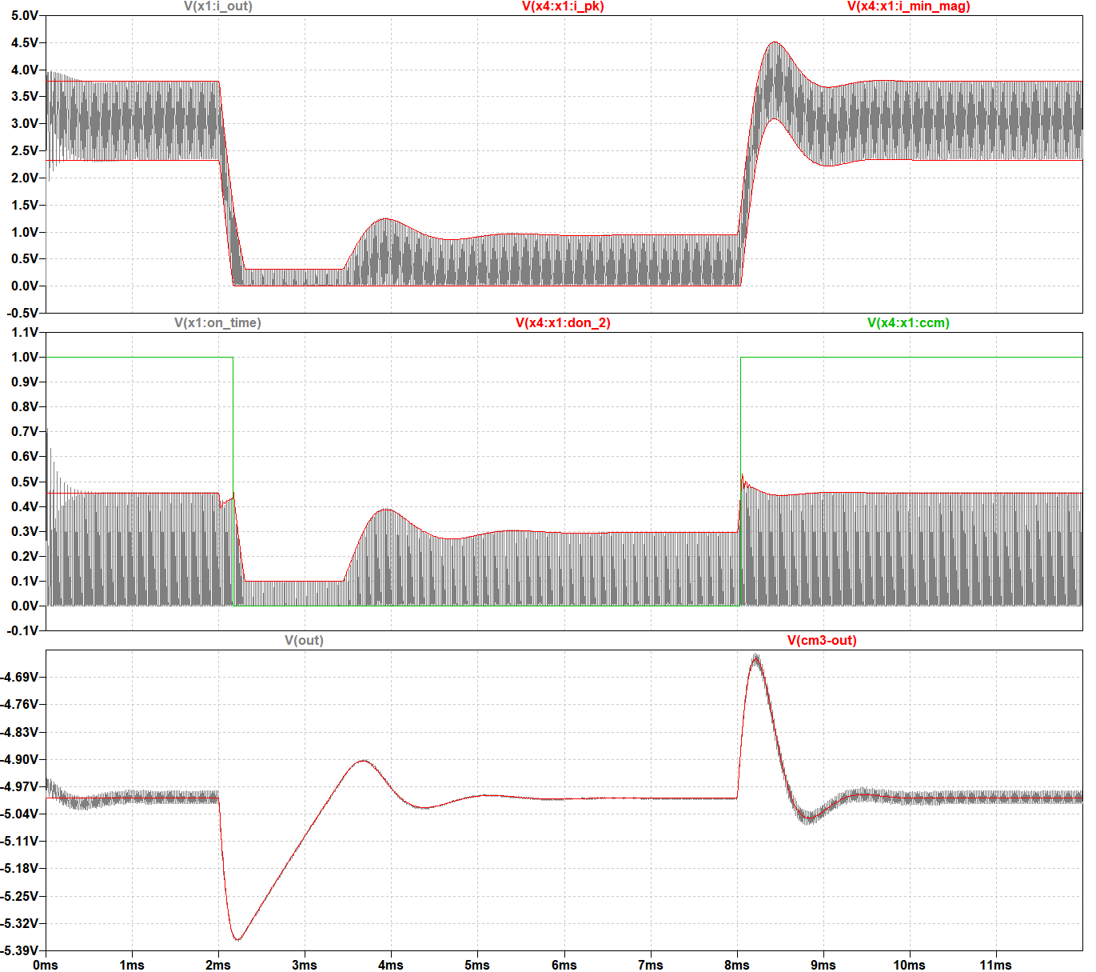

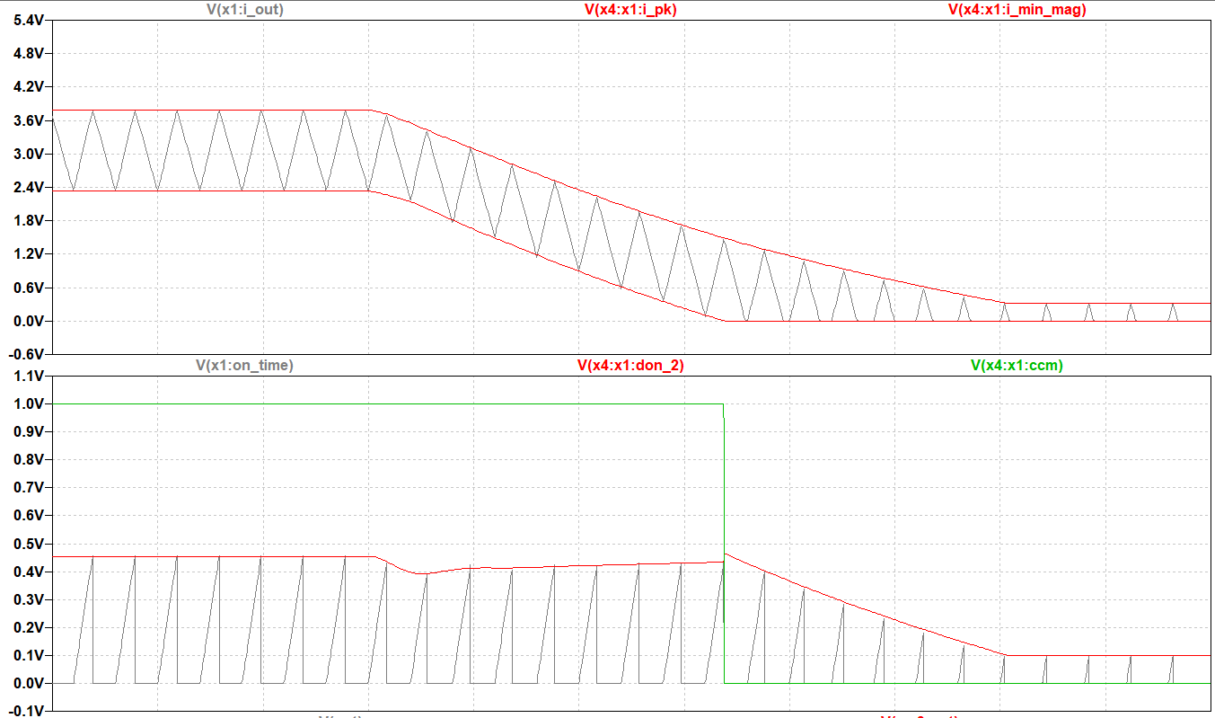

Figure Buck-Boost, Transient Response

# Buck-Boost Negative Input

The Buck-Boost with negative input configuration for the PWM-CM3 is shown in Figure 30. The PWM-CM3 control voltage *CM_Vc* is still referenced to GND but for most Boost controllers the error amp is referenced to the negative rail *CM_a*. In this example the feedback voltage is still referenced to GND but a practical implementation may require a separate shunt regulator like the LM385 to provide a reference and a convenient way to level shift the feedback to the negative input power source.

Figure Buck-Boost Negative Input Parameters

Figure Buck-Boost Negative Input

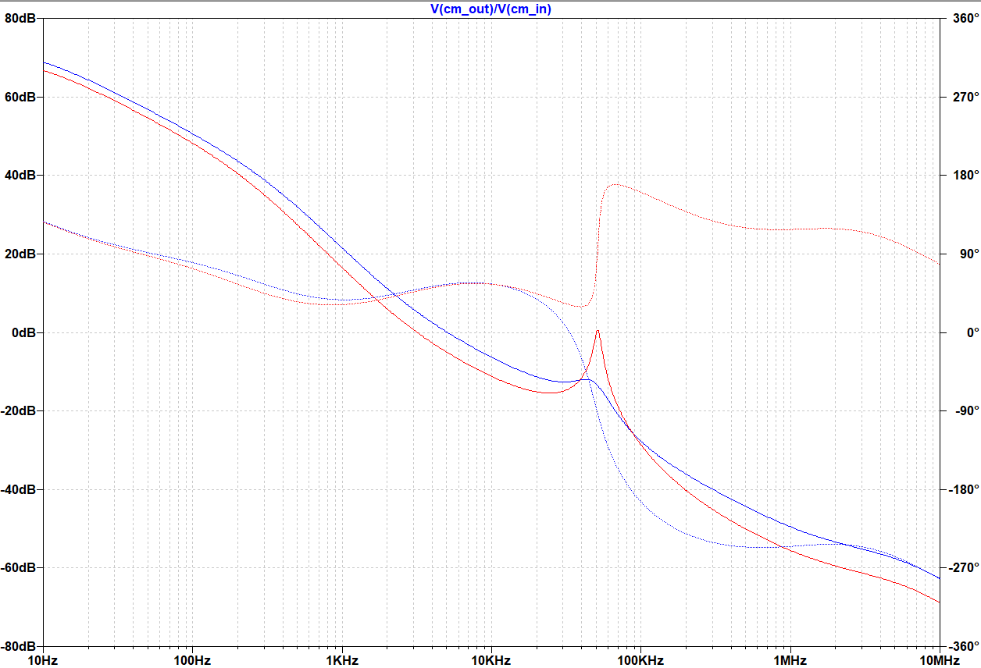

Vout = 6 V

Vout = 4 V

Figure Buck-Boost, Neg I/P, Input Bode Plot

Once again, when the phase increases close to F*s*/2, sub-harmonic oscillations will be present in the output.

# Flyback

The Buck-Boost with negative input configuration for the PWM-CM3 is shown in Figure 35. More windings can be added in parallel with the existing one across ‘c_fly’ and ground. Once again, the averaged model is compared to an Ideal Discrete Time model to verify its operation.

Figure Flyback Input Parameters

Figure Flyback Ideal Discrete Time

Figure Flyback_CM3 Average Model

Figure Flyback PWM-CM3 Configuration

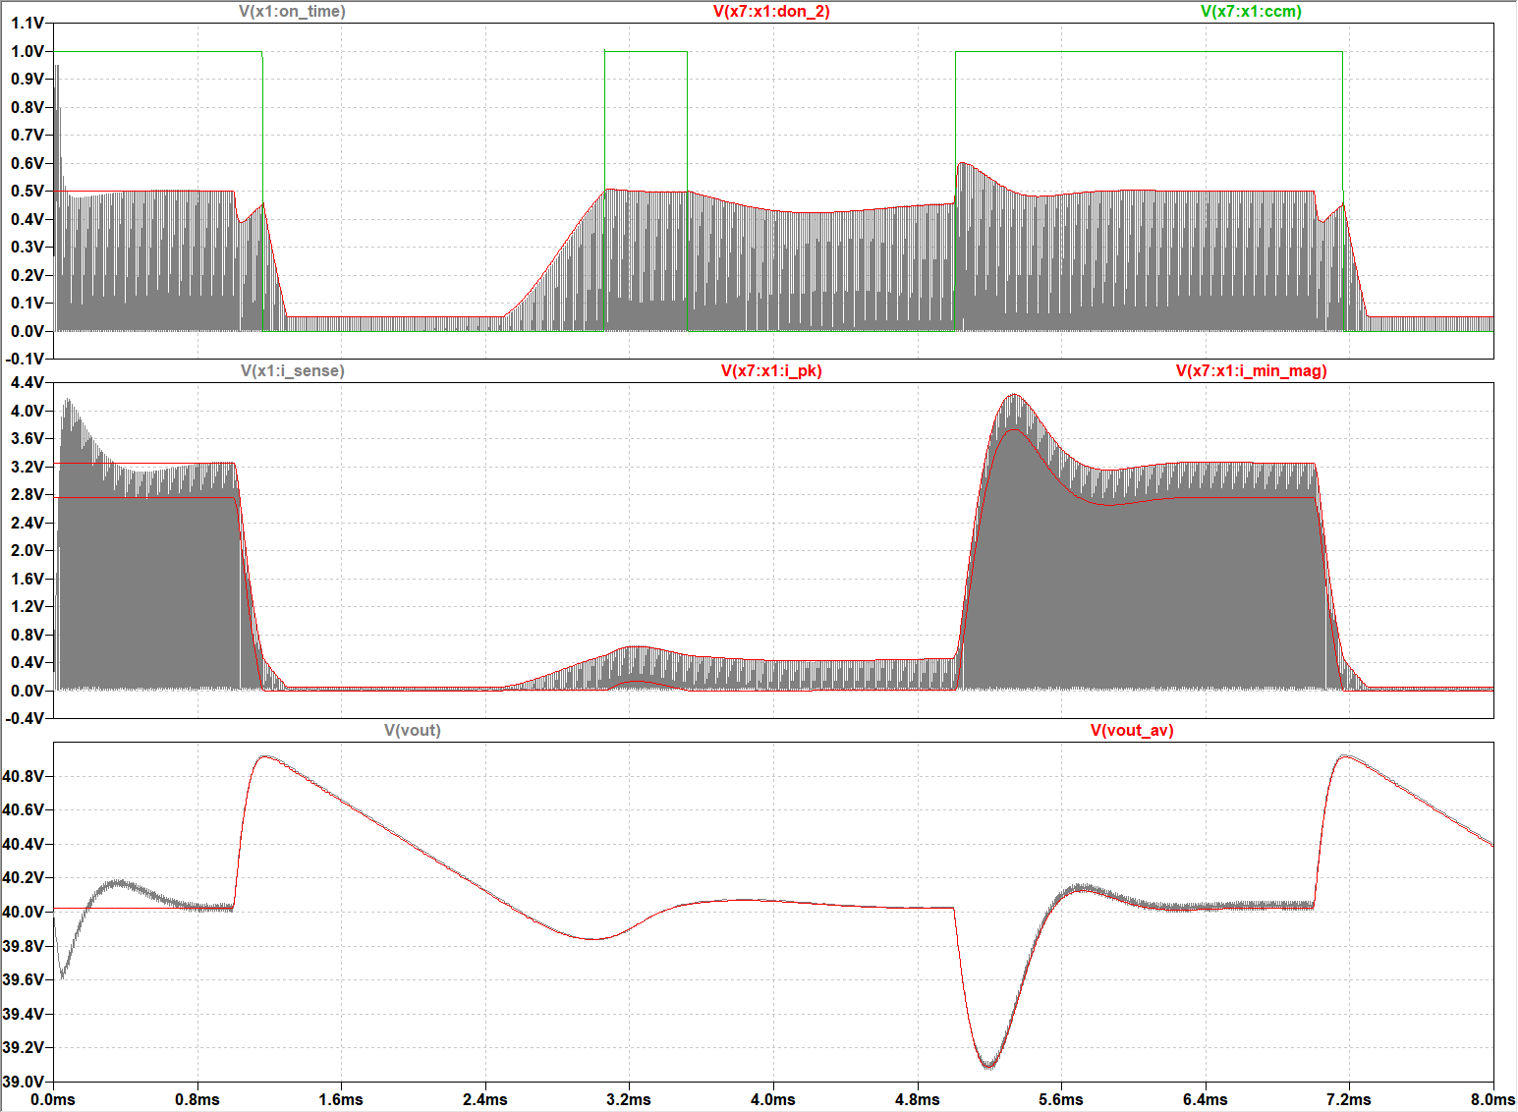

Figure Flyback, Transient Response

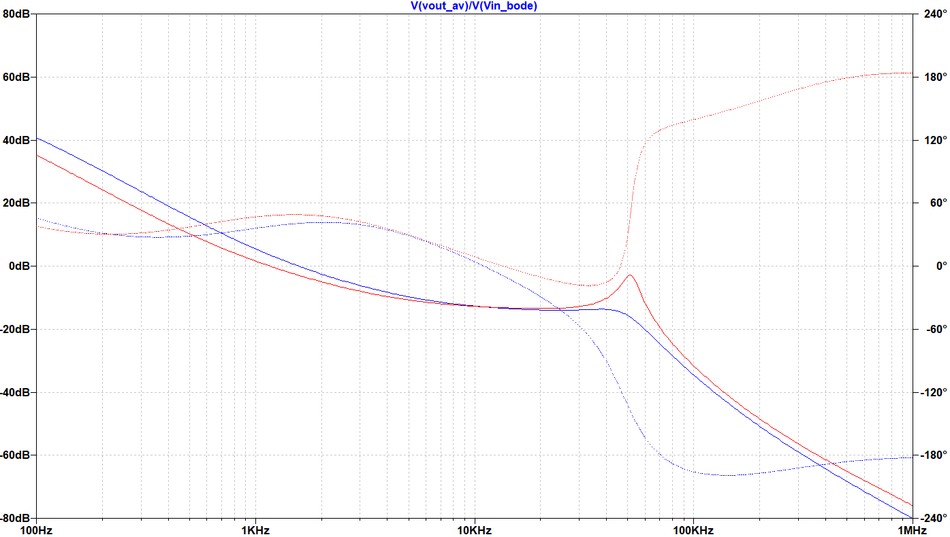

Vout = 50 V

Vout = 30 V

Figure Flyback, AC Response

The Flyback configuration also shows a positive phase shift for the case where sub-harmonics are present.